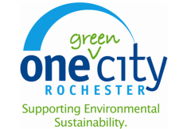
Energy Management and Climate Action Status Report

Prepared by: City of Rochester Division of Environmental Quality

Office of Energy and Sustainability

Overview

This report provides an overview of achievements in energy and climate action realized by the City of Rochester.
The City of Rochester has established within the Division of Environmental Quality the Office of Energy and Sustainability (OES). The goal of the OES is to make the City of Rochester a model for innovative, ecologically sustainable operations, policies and practices, and connect the City with regional and national sustainability resources. This office is responsible for helping the city take advantage of the multiple benefits generated by adopting more sustainable practices. These include reduced operating costs for the City, a healthier, safer more livable community, natural resource conservation and restoration and mitigating and adapting to climate change. Additionally, the office actively solicits grant funding and incentives to implement energy and sustainability projects, from agencies and utilities, including the U.S. Department of Energy (USDOE), New York State Department of Environmental Conservation (NYSDEC), New York State Energy Research and Development Authority (NYSERDA), the New York State Environmental Facilities Corporation (NYSEFC), and Rochester Gas & Electric (RG&E).
OES advocates for and integrates sustainability practices within the key organizational units that can affect change and serves as a catalyst to produce a culture change within the City that integrates sustainability and environmental values into how the City conducts business. This office provides leadership within the City of Rochester relating to the improvement of environmental performance by the City in the following areas:
- climate protection,
- energy efficiency and conservation,
- reduction in fossil fuel emissions
- greenhouse gas management
- stormwater pollution prevention
- hazardous waste management
- petroleum and chemical bulk storage management
- asbestos management
- environmental compliance

As administrator of the City’s Energy and Sustainability program, the OES has provided management and oversight of a wide variety of projects designed to reduce energy consumption and greenhouse gas emissions. The following is a summary of completed and planned projects, as well as results achieved to date in greenhouse gas and energy use reductions.

Greenhouse Gas Emissions Inventory
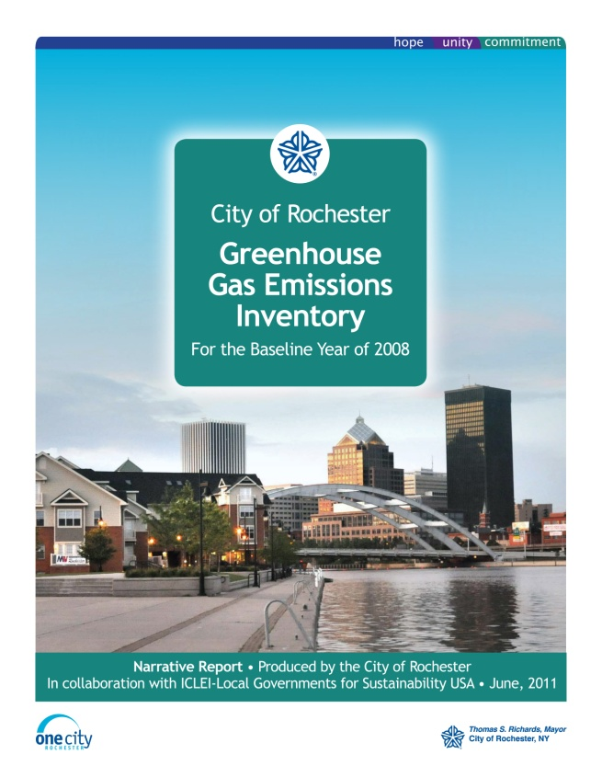
The utilization of fossil fuels for energy contributes to increased levels of greenhouse gasses in the atmosphere. Fossil fuels are used across all sectors: buildings, transportation, streetlights, water production, solid waste, etc. In 2011, the OES completed a greenhouse gas inventory for the baseline year of 2008 to measure greenhouse gas emissions and energy usage by the City. Emissions reductions opportunities can be identified and the effectiveness of greenhouse gas reduction actions can be measured using this report.
To create a framework that guides the planning and implementation of measures, a target greenhouse gas emissions reduction goal of 20% by 2020 has been proposed. Efforts implemented by the city have already resulted in significant emissions reductions. Through the end of 2011, the City has achieved a reduction of almost 5% from 2008 levels. Many more projects have been implemented since 2011 that will show even greater reductions. A summary of projects and initiatives to date follows.

Energy Efficiency

Buildings account for over 40% of energy use and greenhouse gas emissions in the city. As such, energy efficiency and conservation projects in buildings provide the greatest opportunity to reduce energy usage and greenhouse gas emissions in city facilities.
The City has completed many capital projects and implemented reduction initiatives to reduce energy consumption and GHG emissions throughout municipal operations. These actions include:
Utilization of the USEPA online tool, Portfolio Manager, to input and track energy usage in city facilities;
Performing energy audits at City-owned facilities in order to identify potential energy reduction opportunities;
Installation of energy efficient lighting (including controls and fixture replacement) at city facilities, including municipal parking garages, City Hall, Riverside Convention Center, Rundel Library and Genesee Valley Park Recreation Center;
Use of energy management systems in City buildings, including City Hall and the Hemlock Water Filtration Plant;
Upgrading HVAC systems at Charlotte Library, Avenue D Recreation Center and Genesee Valley Park;
Building envelope improvements at the University Avenue Firehouse.

Renewable Energy

To complement energy efficiency and conservation projects, the city is continuously evaluating and implementing where feasible renewable energy at city facilities:
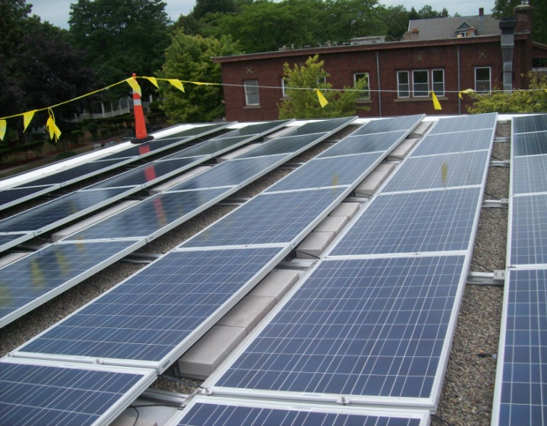
- Purchase of 25% of its electricity from green power generation through Constellation Energy contract
Integration of renewable energy at City facilities, including geothermal energy at Riverside Cemetery and solar photovoltaic energy systems at the Arnett Branch Library (44kW) and the Rochester Public Market (15kW);
Investigation of a former city landfill site on the feasibility of installing up to 2 megawatts of solar energy for net-metering to a city facility through a power-purchase agreement
Arnett Library Solar Panel System

Transportation

Municipal transportation accounts for approximately 36% of greenhouse gas emissions and energy use by the City. Many opportunities exist to reduce the use of fossil fuels in both the City fleet and by the public. Some of the initiatives and projects that have been completed include:
Purchasing and maintaining a City vehicle fleet that includes over 300 alternative fuel vehicles (E-85, compressed natural gas (CNG), hybrid, and electric vehicles);
Design and construction of a new Green Fuel Facility to provide biodiesel, E85 and CNG for the vehicle fleet;
Increased use of bicycle patrols for RPD officers.
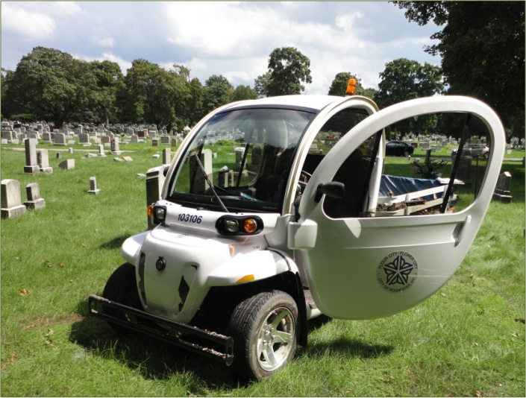
- Automatic Vehicle Locator program, which optimizes vehicle routes to reduce fuel consumption
- Anti-idling policy for city vehicles
- Fleet right-sizing to remove older, less fuel efficient vehicles from the fleet and ensure the correct quantity, type and size vehicle for each function
- Installation of 24 Electric Vehicle Charging Stations at four municipal garages, the City Hall parking lot, and the Public Market (fall 2013)
- Complete Streets Policy to accommodate all users, including pedestrians, bicyclists, transit users and persons with disabilities.
GEM Electric Vehicle
- Utilization of the USDOE’s online Petroleum Reduction Analysis Planning Tool to evaluate the energy and greenhouse gas reductions and cost implications of converting fleet vehicles to alternative fuels.
- Bicycle Enhancement Program installation of bicycle lane markings (i.e., exclusive bicycle lanes and shared use lanes) and associated signage on approximately 15 centerline miles of arterial and collector streets

Materials and Waste Management

Reducing waste to landfills, increasing recycling and use of environmentally friendly products all contribute to reduced greenhouse gas emissions, energy consumption and improved health. Some of the programs and initiatives completed by the City in this area include:
Use of green cleaning products at City facilities;
Green purchasing policy development
Solar trash compactors and cardboard recycling at the Public Market

Climate Change Adaptation and Green Infrastructure
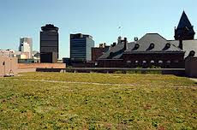
City Hall Green Roof
Inevitable changes in climate require cities to be prepared for more frequent and severe heat waves, excessive rain events and flooding, and changes in temperature and precipitation. Installation of green infrastructure helps mitigate these affects, while also contributing to greenhouse gas and energy use reductions. The City has been successful in the design and construction of the following green infrastructure projects:
Green roof installation at City Hall;
Installation of a permeable pavement parking lot at City Hall (construction planned for spring 2014);
Permeable pavement parking lot and rain gardens installations at Turning Point Park;
Port of Rochester parking lot bio-retention and permeable paver areas;
Construction of a new Emerson and Locust Green Connector Street (Sawdey Way);
Durand Eastman Park Smart Sponge water quality improvement project;
Cornerstone Park Green Infrastructure retrofits such as porous pavement and rain gardens (design RFP released, 2013) ;
Installation of porous tree pits in Center City; and
Riverside Cemetery Rain Garden

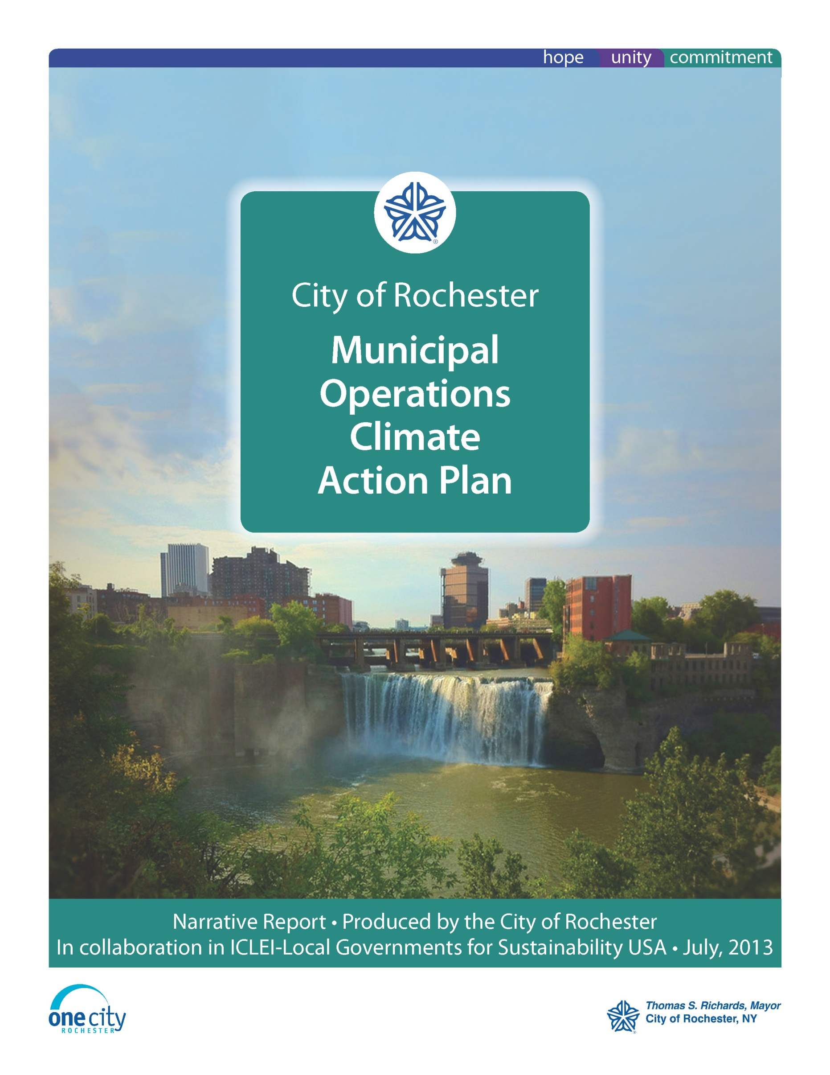
Planning

Energy and sustainability planning efforts designed to lay out a path for greenhouse gas emission and energy use reductions and sustainable development that are currently completed or in progress include:
- Finger Lakes Regional Sustainability Plan
- Municipal Operations Climate Action Plan
- Cleaner Greener Communities Comprehensive plan update-City of Rochester Sustainability Plan
- New York Power Authority Energy Master Plan project
- Permitting/zoning updates to address PV (solar) and EV charging station installation

Leadership

The City of Rochester has demonstrated leadership in the areas of climate protection and energy management both in leading by example and through in the following commitments and partnerships:
- Rochester City Council Resolution in Support of Climate and Environment Protection
- NYS DEC designated “Climate Smart Community”
- ICLEI Cities for Climate Protection Member
- USDOE Better Buildings Challenge Partner
- USEPA Green Power Partnership

Grant Funding/Incentives

The OES has been successful in securing and managing grant funding and utility incentives from a variety of sources to assist in the implementation of the climate and sustainability initiatives and projects described in this report. Since 2009, the OES has secured over $6,577,436.00 in grant funding and incentives:
US DOE Energy Efficiency and Conservation Block Grant: $2,199,800.00
NYSERDA :
Alternative fuel vehicle purchases: $26,180.00
High Falls lighting upgrade: $145,000
Arnett Solar: $215,000
Electric Vehicle Supply Equipment: $227,793.00
NYSDEC Water Quality Improvement Program: $2,005,500.00
NYSEFC Green Innovation Grant Program:
Turning Point Park: $552,000.00,
Port of Rochester : $198,000.00
NY Dept. of State Local Waterfront Revitalization Program: $250,000.00 (Port green infrastructure)
Genesee Region Clean Communities/CMAQ: $200,000.00 (CNG vehicle purchases)
CMAQ:
Electric Vehicle Supply Equipment: $109,200.00
Electric vehicle purchases: $112,025.00
RG&E Energy Efficiency Incentives:
Sister Cities Garage Lighting Upgrade: $117,900.00
Midtown Garage Lighting Upgrade: $ 202,288.50
Recreation Centers/Library/Public Market Upgrades: $8,750.00
Riverside Cemetery Geothermal System: $8,000.00

Results

By utilizing the Portfolio Manager tool, the City actively tracks ongoing results of energy programs and projects as well as identifies areas to concentrate future investments in energy efficiency and conservation. The overall portfolio of city facilities tracked in Portfolio Manager shows an approximate 14% overall energy use reduction from reported facility baselines and an approximate 11% reduction in site energy use intensity (kBtu/ft²). Notably, in facilities where investments in energy efficiency have been made, much larger reductions have been realized. For example in City facilities where EECBG funding was utilized for energy efficiency upgrades, there has been an average overall energy usage reduction of approximately 30% and a 23% improvement in energy use intensity. Additionally, approximately 25% of city facilities have already met the DOE Better Buildings Challenge goal of 20% energy use intensity reduction by the year 2020. The table below illustrates energy use intensity reductions for city facilities categorized by a various groups:
Property Type | Baseline Average Site EUI (kBtu/ft²) | Current Average Site EUI (kBtu/ft²) | % Improvement
City facilities upgraded through DOE EECBG Program | 28.5 | 21.8 | 23
Rochester Fire Department | 115.3 | 99.4 | 14
Recreation Centers | 100.2 | 81.7 | 19
Rochester Public Library System | 64.1 | 56.7 | 8
DES Water Treatment Facilities | 252.8 | 234.7 | 7
General City buildings | 72.2 | 73.1 | -1
Municipal Parking Garages | 7.2 | 5 | 31
Parks Buildings | 93.9 | 84 | 10
Rochester Police Department | 122.7 | 125.7 | -2
DES Buildings | 94.3 | 70.7 | 25

Greenhouse gas reductions over all of City operations and facility sectors have been calculated through the end of 2011. The table below shows these reductions. Note that this table does not take into consideration the multiple projects in these sectors completed since 2011, but still shows an overall reduction of almost 4% from the baseline year of 2008.

Sector | 2008 GHG Emissions | 2011 GHG Emissions | % Reductions
Buildings & Facilities | 13,161 | 12,001 | 8.81
Vehicle Fleet | 11,819 | 11,767 | 0.44
Water Delivery Facilities | 1,946 | 1,713 | 11.9
Streetlights | 5,808 | 5,768 | 0.69
Port Facilities | 307 | 555 | -80.8
Overall | 33,039 | 31,804 | 3.74

Note that the increase in greenhouse gas emissions at the Port facility is due to the opening of the Pier 45 restaurant

Next Steps

Finalization of the City of Rochester Municipal Operations Climate Action Plan (expected September, 2013) providing a roadmap for City actions, projects and programs to achieve continued reduction in greenhouse gas emissions and energy use.
Continued tracking of progress toward meeting the City’s target reduction goals in City facilities using Portfolio Manager
Repeat municipal greenhouse gas inventory in 2015 to measure progress toward emissions reductions across all sectors.
Utilization of funding from energy rebates and energy savings to complete additional projects at city facilities
Implement new programs and projects to further reduce energy use and greenhouse gas emissions, addressing areas such as employee awareness, electronics energy use reduction and solid waste reduction initiatives
Update City comprehensive plan to address sustainability, including efforts focusing on updating zoning ordinances, and addressing climate resiliency intended to save energy, increase use of renewable energy, reduce greenhouse gas emissions across the City.
Continue to actively pursue grant funding opportunities for climate change mitigation and energy improvement projects

